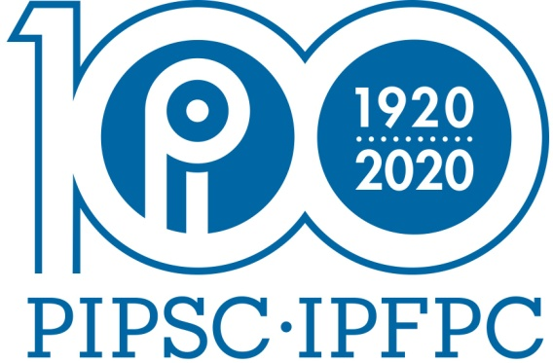
The Professional Institute of the Public Service of Canada

Group Participation in Our History

The Professional Institute will be celebrating its 100th Anniversary on February 6, 2020. In preparation for this event, the 100th Anniversary Committee is gathering current and historical information about PIPSC and its various entities. The Groups are an important and integral part of the organization of PIPSC and we would appreciate it if you could take a few minutes to fill out this questionnaire and return it to 100anniversary@pipsc.ca.

Questionnaire

- Group Name

- Approximate number of Members in the Group

- Please give a brief description of the professions represented by the Group

- Year when Group became affiliated with PIPSC and manner in which group became affiliated (i.e., 1920; one of the original members to form PIPSC)

- Have there been any changes to the group structure/membership since its inception? If yes, what were those changes and why did they occur?
(i.e., During the Universal Classification System exercise, the group was expanded to include other professions which were previously separate groups within PIPSC)

- What would you consider to be milestones in your Group’s history with PIPSC?

- What has been your Group’s role with and impact on PIPSC?

- Are there individuals in your Group who played a leadership role in PIPSC? If yes, then please identify them and the role they have played.

- Are there events or stories about your members and/or your Group which you would like to share with us?

- Can you suggest individuals that the 100th Anniversary Committee can contact for information on the history and evolution of your group? If you have any contact information for those individuals, please provide it to the committee.

