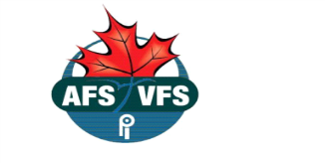

Calgary and Southern Alberta AFS Sub-Group

NOMINATION FORM – 2018-2019 EXECUTIVES

I wish to nominate:
Employer: | Canada Revenue Agency
For the position of:
Nominated by:
Signature:
Nomination seconded by:
Signature:
I accept the nomination for the position of:
Signature:

Submit completed nomination form in a sealed envelope to Election Committee Chair, Farzana Merani at POD 3022B by 5:00 pm on March 21, 2018

